This project is designed for use with a high school rockets or physics class. Newton’s laws and the kinematic equations are used to estimate performance.

The characteristics of the rocket are entered into the GUI:

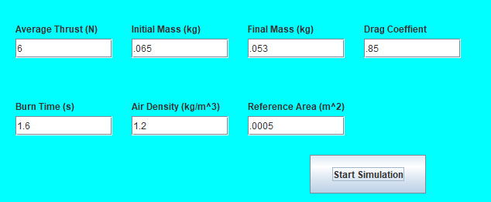

Once the simulation is started, a graph of acceleration, velocity and height versus time is produced:

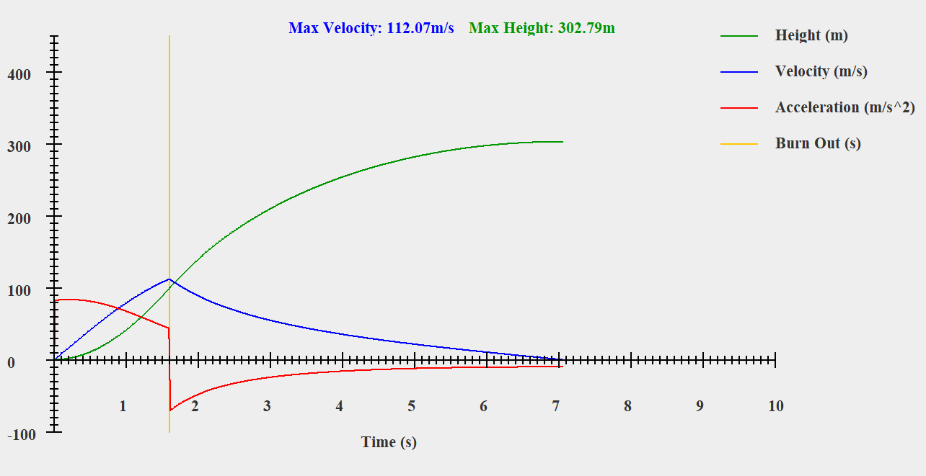

This graph shows max velocity and height. The program takes into consideration the change in mass during burn phase and the change in drag with the change in velocity. This graph gives a good estimate of performance along with what the delay charge of the motor should be.

The class launches a rocket with an altimeter and compares the results to the performance estimated by the graph, then reports on the findings.